🌐 Web Application Architectures
- Combine technology and design to shape digital experiences.
- Two main approaches:
  - Layered architectures (N-tier/monolithic)
  - Microservices architectures

🏗️ Layered Architectures (N-tier)
- Common in monolithic applications.
- Divide application into distinct layers → clear separation of tasks.
- Easier to start with, suitable for blogs, ecommerce, etc.
Layers:
- Frontend (Presentation Layer)
  - Handles user interfaces and interactions.
  - AWS services: Amazon EC2, Amazon S3 (static sites), Elastic Load Balancing, CloudFront (CDN), API Gateway.
- Application Layer (Middle Tier)
  - Contains business logic, processes requests, orchestrates data flow.
  - AWS services: Amazon EC2, AWS Lambda (serverless), AWS Step Functions (workflow orchestration).
- Database Layer
  - Manages data storage and retrieval.
  - AWS services: Amazon EC2 (custom DB), Amazon RDS (relational DBs), Amazon DynamoDB (NoSQL).
Note:
- Amazon EC2 can be used at every layer → flexible but requires OS management.

🔹 Microservices Architecture
- Application built as independent services communicating via APIs.
- Each service performs a single function and can be:
  - Developed, deployed, and scaled independently.
  - Owned by small, self-contained teams.
- Benefits: faster development, easier scaling, supports innovation.

⚖️ Monolithic vs. Microservices
- Monolithic:
  - All processes tightly coupled, run as one service.
  - Scaling requires scaling the entire application.
  - Complexity grows with codebase → harder to add features.
  - Higher risk: one failure can affect the whole system.
- Microservices:
  - Independent components, each with its own service.
  - Communicate via lightweight APIs.
  - Easier updates, deployments, and scaling per function.
- Encourages experimentation and faster time-to-market.
- 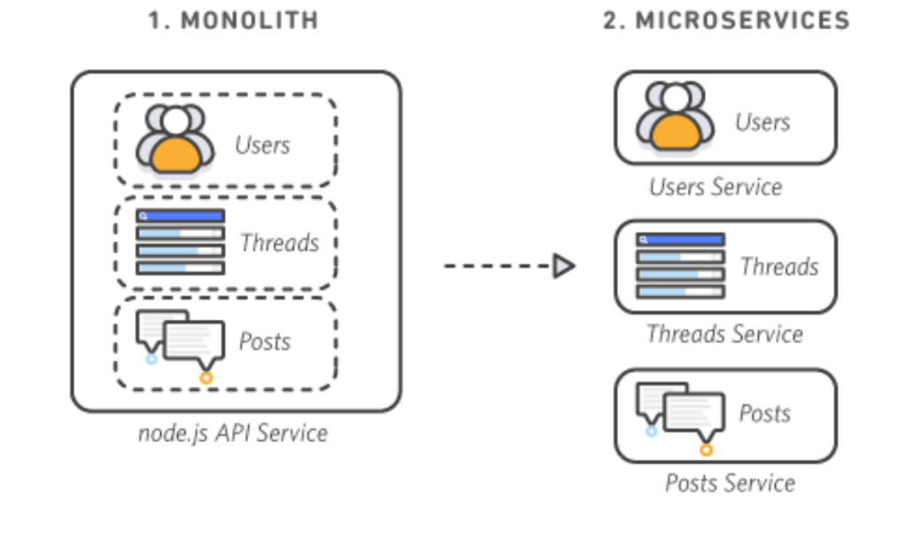

🔹 Characteristics of Microservices
- Autonomous
  - Each service can be developed, deployed, operated, and scaled independently.
  - Communication happens via well-defined APIs.
- Specialized
  - Each service focuses on solving a specific problem.
  - Complex services can be broken down into smaller ones.
- Agile
  - Small, independent teams own services.
  - Faster development cycles and higher throughput.
- Flexible Scaling
  - Services scale independently based on demand.
  - Enables right-sizing infrastructure and cost measurement.
- Easy Deployment
  - Supports CI/CD pipelines.
  - Facilitates experimentation, quick updates, and rollbacks.
- Technological Freedom
  - Teams choose the best tools for their specific needs.
  - No one-size-fits-all approach.
- Reusable Code
  - Services act as modular building blocks.
  - Functions can be reused across features.
- Resilient
  - Service independence reduces risk of total application failure.
  - Failures degrade functionality instead of crashing the whole system.

⚙️ AWS Services for Microservices
- Compute
  - Amazon EC2 → versatile compute resources.
  - Amazon ECS → container management (Docker).
  - AWS Lambda → serverless execution for microservices.
- Storage & Databases
  - Amazon EC2 → custom database hosting.
  - Amazon RDS → managed relational databases.
  - Amazon DynamoDB → scalable NoSQL database.
- Networking
  - Application Load Balancer → advanced traffic routing.
  - Amazon API Gateway → manage APIs at scale.
  - Amazon Route 53 → DNS for APIs.
- Messaging
  - Amazon SNS → pub/sub messaging service.
  - Amazon SQS → message queuing for decoupling services.
- Logging & Monitoring
  - Amazon CloudWatch → metrics, logs, alarms, automated reactions.
  - AWS X-Ray → request tracing, centralized log view, troubleshooting.

